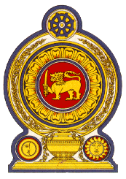

Statement by the Democratic Socialist Republic of Sri Lanka
29th Session of the Universal Periodic Review
Review of France – 15 January 2018

Mr. President,

Sri Lanka welcomes the delegation of France and appreciates the comprehensive national report and the presentation made this morning. We congratulate France for the achievements and the progress made in the follow up to its second UPR.

We are pleased to note the progressive actions taken by the Government of France in recent years through executive, legislative and judicial measures to combat racial discrimination and xenophobia, including the National Action Plan to Combat Racism. Sri Lanka recommends that France continues to take actions to promote understanding, tolerance and friendship among the different racial and ethnic groups, in particular the minority groups, in France.

While taking note with interest, the positive interventions of the Government on equality in employment and political life, such as the establishment of the High Council for Gender Equality in 2013 as an advisory body under the Office of the Prime Minister, Sri Lanka recommends that France continues to implement measures to advance gender equality and combat discrimination against women in all spheres including in political, and economic activities.

We wish France success in its UPR engagement.

Thank you.

