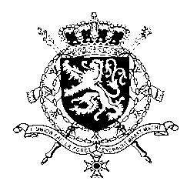
Représentation permanente de la Belgique auprès des Nations Unies et auprès des institutions spécialisées à Genève

WG UPR – United Arab Emirates
Belgian intervention
22nd of January 2018

Mr. President,

Belgium acknowledges the positive steps the Government of the United Arab Emirates has taken with respect to the implementation of recommendations accepted during its second UPR, notably on worker rights.

However, further progress is needed in this field as well as in other areas, in particular regarding the prevention of violence against women, and the situation of human rights defenders.

In this regard, Belgium would like to recommend to the United Arab Emirates:

R1. To enact comprehensive legislation to address violence against women, including the recognition of domestic violence as an offence;

R2. To take the necessary measures to ensure that human rights defenders can exercise their work in a safe environment, free from harassment and intimidation.

As a strong proponent of the abolition of the death penalty, Belgium would also like to recommend:

R3. To reinstate a moratorium on the use of the death penalty with a view of abolishing the practice.

Thank you, Mr. President

