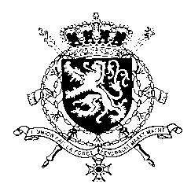
Représentation permanente de la Belgique auprès des Nations Unies et auprès des institutions spécialisées à Genève

WG UPR – Barbados
Belgian intervention
19th January 2018

Mr. President,

Belgium welcomes the delegation of Barbados. We acknowledge that positive steps have been taken by Barbados with respect to the implementation of recommendations accepted during its second UPR. However, Belgium is convinced that further progress can still be achieved to increase the protection of human rights in line with the core international human rights treaties.

Therefore, we would like to formulate the following recommendations:

R1. Ratify the Second Optional Protocol to the International Covenant on Civil and Political Rights, aiming at the abolition of the death penalty.

R2. Ratify the Convention against Torture and Other Cruel, Inhuman or Degrading Treatment or Punishment (CAT) as well as the International Convention for the Protection of all Persons from Enforced Disappearance (CED).

Furthermore, Belgium attaches a lot of importance to the rights of the child and therefore recommends Barbados to

R3. Expedite the adoption of a Juvenile Justice Bill in order to inter alia outlaw the use of corporal punishment as a criminal sanction.

Thank you, Mr. President.

