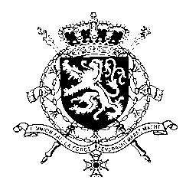
Représentation permanente de la Belgique auprès des Nations Unies et auprès des institutions spécialisées à Genève

WG UPR – The Bahamas
Belgian intervention
17th January 2018

Mr. President,

Belgium welcomes the delegation of the Bahamas and acknowledges that positive steps have been taken by the Bahamas with respect to the implementation of recommendations accepted during its second UPR. However, Belgium is convinced that further progress can still be achieved to increase the protection of human rights in line with the core international human rights treaties.

Therefore, we would like to formulate the following recommendations:

R1. Ratify the Second Optional Protocol to the International Covenant on Civil and Political Rights, aiming at the abolition of the death penalty.

Belgium welcomes the signing of the Convention against Torture and Other Cruel, Inhuman or Degrading Treatment or Punishment (CAT) by the Government of the Bahamas in 2008. We encourage the Government to go one step further and recommend to:

R2. Ratify the Convention against Torture and Other Cruel, Inhuman or Degrading Treatment or Punishment (CAT).
and to
R3. Ratify the International Convention for the Protection of all Persons from Enforced Disappearance (CED).

Thank you, Mr. President.

