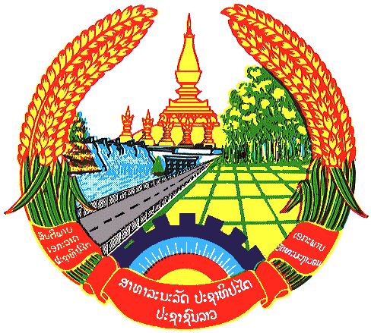

Statement by the delegation of the Lao PDR
At the 29th Session of UPR Working Group
Geneva, 15-26 JANUARY 2018

Review of Mali: 16 January 2018, at 14:30 - 18:00 hours

Mr. President,
The Lao delegation warmly welcomes the delegation of Mali and thanks for the comprehensive presentation of the national report.

My delegation commends the government of Mali for its efforts to implement the recommendations accepted in the last UPR and we welcome the Strategic Framework for Economic Recovery and Sustainable Development of the government of Mali which is to promote inclusive and sustainable development in order to reduce poverty and inequality in a unified and peaceful Mali on the basis of the Agenda 2030 Sustainable Development Goals.

My delegation would like to make three recommendations:
- To continue in strengthening capacity building of the State and non-State actors working in the human rights field;

- To further work on protection of the rights of women to ensure its full respect;

- To continue its cooperation with the UN, other International Organizations and human rights mechanisms to overcome remaining constraints and challenges.

My delegation wishes Mali every success in its the third cycle of UPR.
I thank you, Mr. President.

