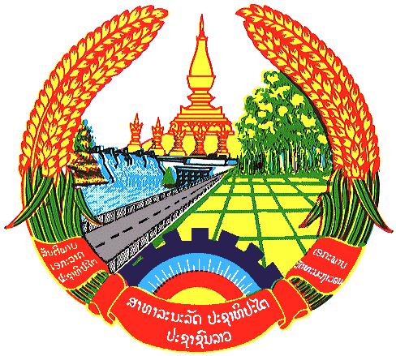

Statement by the delegation of the Lao PDR
At the 29th Session of UPR Working Group
Geneva, 15 – 26 January 2018

Review of Luxembourg: 18 January 2018, at 14:30 - 18:00 hours

Mr. President,
Lao delegation warmly welcomes the delegation of Luxembourg to the 29th Session of the UPR Working Group and would like to thank for the comprehensive presentation of the National Report.

My delegation commends the government of Luxembourg on its efforts on the protection and promotion of human rights in the country and pleased to note that Luxembourg is currently a party to many core international human rights instruments among other conventions.

Lao delegation welcomes the National Action Plan to Combat Human Trafficking of Luxembourg which focuses its efforts in identification and protection of victims; pursuit and prosecution of traffickers; and encourages an active and effective anti-trafficking policy. We recommend that Luxembourg continues its efforts to strengthen the capacity in action in a fight against human trafficking and particularly combating violence against women and girls.

Laos wishes Luxembourg every success in its third cycle of UPR.
I thank you, Mr. President.

