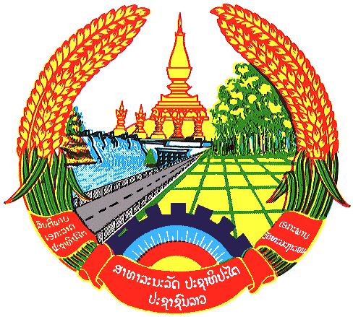

Statement by the delegation of the Lao PDR
At the 29th Session of UPR Working Group
Geneva, 15-26 JANUARY 2018

Review of France: 15 January 2018, at 09:00 - 12:30 hours

Mr. President,
The Lao Delegation warmly welcomes the Delegation of the French Republic to the 29th Session of the UPR Working Group and would like to thank for a comprehensive presentation of the National Report on human rights.

My delegation commends measures taken by the Government of France to implement the previous UPR recommendations and congratulates its ratification the Optional Protocol to the International Covenant on Economic, Social and Cultural Rights and the Third Optional Protocol to the Convention on the Rights of the Child on a communications procedure.

My delegation is pleased to note that defending women’s rights, promoting equality between women and men and combating gender violence are the priorities of French foreign policy.

My delegation would like to make following recommendations:

- Continue strengthen of legislation of the Interministerial Mission for the protection of women from violence and combating trafficking in human beings. and
- Continue assistance, promotion and protection of the rights of persons with disability.

My delegation wish France every success in its Third Cycle of UPR.

I thank you, Mr. President.

