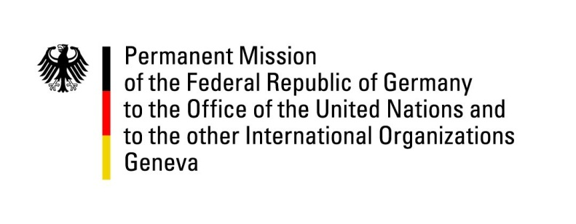

United Nations Human Rights Council

29th Session of the UPR Working Group

Geneva, 22 January 2018

Recommendations and advance questions to the
United Arab Emirates

Thank you, Mr. President.

Germany welcomes the delegation of the United Arab Emirates to the third cycle of the UPR.

Germany commends the United Arab Emirates for its efforts to improve the legal situation of children. In particular, we welcome the adoption of a law safeguarding rights of children in June 2016 which led to an increase in the number of reports regarding cases of violence or negligence against children.

Germany, however, remains concerned by restrictions on the freedom of expression and human rights defenders and continuing violations of the rights of women.

Germany therefore offers the following recommendations:

- Strengthen the promotion and protection of the rights of women and their equality, including by amending the Federal Law No. 2 of 2015 to include gender discrimination;
- Ensure the swift establishment of an independent National Human Rights Institution in line with the Paris Principles as announced in 2013;
- Strengthen the constitutional right of freedom of expression by becoming a state party of the ICCPR;
- Cooperate with UN human rights mechanisms, including by responding positively to visiting requests by special procedure mandate holders.

Thank you, Mr. President.

GERMAN ADVANCE QUESTIONS TO THE UNITED ARAB EMIRATES:

- During the second cycle of the UPR in 2013, the United Arab Emirates committed itself to the establishment of an independent National Human Rights Institution (NHRI) in line with the Paris Principles. Germany would like to know how well-advanced the efforts for the setting up the NHRI are so far?

- Thousands of long-term residents in the United Arab Emirates are not allowed to obtain the citizenship. These families have not had any official documents for decades and thus are deprived from access to health care, education and other basic services. What steps have the United Arab Emirates recently taken to seriously improve the human rights situation of the so-called Bidoon?

- How do the United Arab Emirates guarantee the right to freedom of opinion and expression and the right to privacy, including online, in light of the cybercrime law (No. 5 of 2012)?

