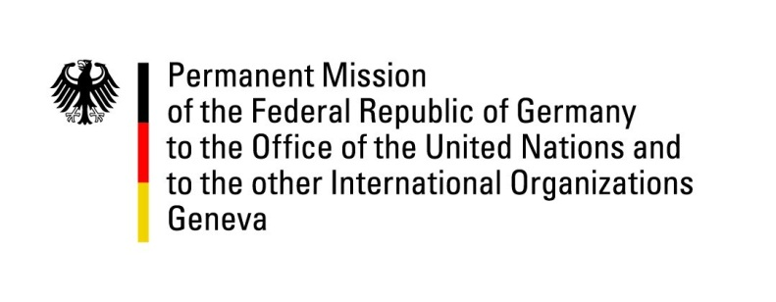

United Nations Human Rights Council

29th Session of the UPR Working Group

Geneva, 15 January 2018

German questions and recommendations to

Tonga

Mr. President,
Germany commends the government of Tonga on the recent accession to the International Labor Organization, which constitutes an important step towards the goal of guaranteeing full protection of the human rights of employees.
We are concerned about the human rights situation of women and other vulnerable groups, including people with disabilities and LGBTI, leading to the following recommendations:
- Ratify the Convention on the Elimination of All Discrimination against Women, and implement it in national law.
- De-criminalize consensual same-sex relations.
- Introduce comprehensive anti-discrimination legislation to provide equal protection for all persons, including vulnerable groups like people with disabilities, and on all grounds, including sexual orientation and gender identity.
We thank you, Mr. President.

Questions submitted in advance:
- When does the government of Tonga plan to ratify instruments like ICCPR, ICESCR, CEDAW and CAT?
- What improvements with respect to gender equality have been made in recent years? And what measures will the government take in order to further improve women’s rights and acceptance and lower discrimination?
- What legal improvements have been made in order to meet the needs of persons with disabilities and what further measures are planned in the future? Is there a timeframe for the ratification of CRPD?

