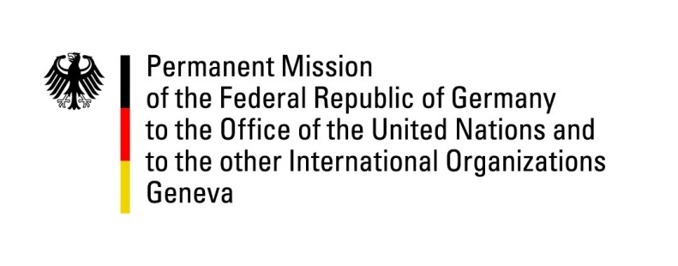

United Nations Human Rights Council
29th Session of the UPR Working Group

Geneva, 16 January 2018
---
Recommendations and advance questions
to
Romania

Mr. President,

Germany welcomes the delegation of Romania to the UPR and commends Romania for its engagement with the Human Rights Council and for progress made with regards to the work of the “National Council for Combatting Discrimination”.
At the same time, Germany remains concerned about the human rights situation of persons belonging to vulnerable groups, including Roma and LGBTI.
Germany offers the following recommendations:
1. Adopt as quickly as possible the Multi-Annual Strategy on Preventing and Combatting Discrimination.
2. Systematically collect and publish disaggregated statistical data concerning hate crimes, which should include information on the motives of the perpetrators.
3. Accelerate the adoption and budgeting of the National HIV/AIDS Strategy 2018-2020 and of the National Strategy on Sexual and Reproductive Health and Rights.

Thank you Mr. President.

Advance questions to Romania:

1. Which steps has Romania initiated in order to swiftly resolve child abductions, in particular the prompt implementation of custody verdicts of other EU member states?
2. Which legal measures does Romania plan to implement in order to improve the situation of transsexuals, especially regarding medical care and change of gender or name in legal documents?
3. What are the results of the national strategy and the measures for the inclusion of Roma in the Romanian society?
4. What is the position of the Romanian Government regarding the planned referendum which wants to alter the definition of family within the Romanian Constitution and thus exclude children and their single parents as well as same-sex couples from the fundamental right protection for families?

