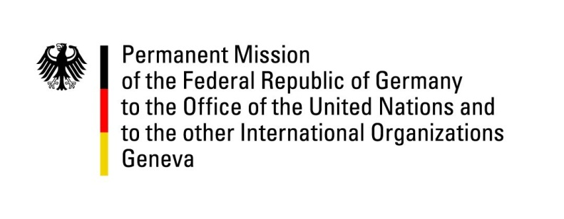

United Nations Human Rights Council

29th Session of the UPR Working Group

Geneva, 22 January 2018

German recommendations and questions
to Montenegro

Thank you, Mr. President.

Germany welcomes the delegation of Montenegro to the UPR. We commend Montenegro for the improvements it has achieved since the last UPR in 2013. These include the extension of the mandate of the Protector of Human Rights and Freedoms in December 2016 as well as improvements of the situation of LGBTI persons. Moreover, we welcome Montenegro’s collaboration with civil society in the preparation of this UPR review.

However, there still remains significant potential for improvement of the situation of the LGBTI community as well as for the protection of the freedom of opinion and of the press in particular. Moreover, the phenomenon of selective abortions of female fetuses needs to be addressed in an effective manner. In this line, we would like to offer the following recommendations:

- Work out, in a timely fashion, a concrete draft law for the legalization of same sex partnerships which can be passed expeditiously by parliament;
2) Reinstate the commission for the investigation of assaults on journalists and commit it to publish, on a regular basis, activity reports on the scope and quality of its cooperation with other governmental agencies;
3) Install more effective control mechanisms for hospitals which perform prenatal genetic tests for the detection of sex in fetuses. Due to the transnational nature of the issue, a close coordination with Serb governmental agencies should be targeted.

Thank you, Mr. President.

GERMAN ADVANCE QUESTIONS TO MONTENEGRO:
- What measures does Montenegro undertake to increase the school enrolment of children from the Roma, Egyptian and Ashkali communities and are there initiatives for a better integration of adult members of these communities into the labour market?
- What does Montenegro do in order to investigate assaults on journalists, clearing a considerable backlog? What are the reasons for the lack of support for the meanwhile suspended investigative commission, which was tasked with looking into these cases?
- What findings does Montenegro have on the selective abortion of female foetuses and what does it do to counteract this phenomenon?

