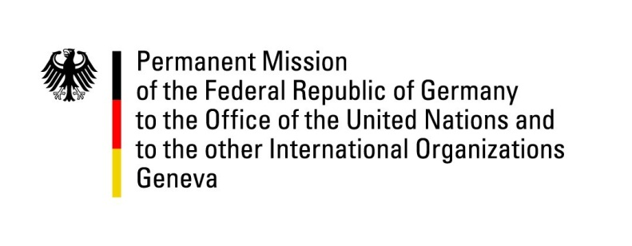

United Nations Human Rights Council
29th Session of the UPR Working Group

Geneva, 16th January 2018

German recommendations and advance questions
to
MALI

Mr. President,
Germany welcomes Mali to the UPR and commends its progress in the field of transitional justice, especially by the operationalization of the regional offices of the Justice, Truth and Reconciliation Commission. Germany further welcomes the establishment of a National Human Rights Institution.

Germany recommends:

- Investigate and prosecute all allegations of human rights violations, including those committed by security forces, and introduce a mechanism of internal oversight for the security forces.

- Adopt criminal laws prohibiting all forms of female genital mutilation and cutting and initiate a public debate addressing harmful traditional practices.

- Repeal the Persons and Family Code to bring it in line with the Constitutional prohibition of gender based discrimination including by granting equal succession rights to women and girls and raising the minimum age of marriage for girls to 18 years.

- Develop a strategy and allocate the resources necessary to ensure the National Human Rights Institution fully complies with Paris Principles.

- Pass the draft law for the Recognition and Protection of on strengthening human rights defenders.

Thank you.

German advance questions to Mali:

- What steps have so far been taken by the Republic of Mali to introduce a law penalizing female genital mutilation and to allocate resources to ensure the implementation of the national action plan to combat female genital mutilation?

- What steps are being taken to have the national assembly pass the draft law for the Recognition and Protection of human rights defenders as adopted by the government in January 2017?

