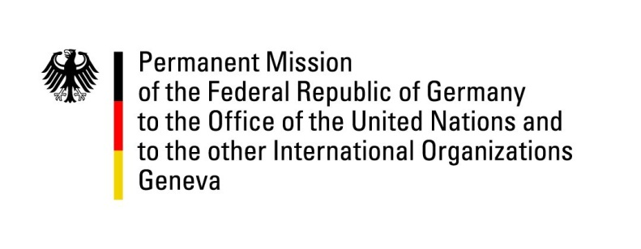

United Nations Human Rights Council

29th Session of the UPR Working Group

Geneva, 24 January 2018

German questions and recommendations to
Liechtenstein

Thank you, Mr. President.
Germany welcomes the delegation of Liechtenstein to the third cycle of the UPR. We praise Liechtenstein for its constructive engagement with the mechanisms of this Council and appreciate the efforts undertaken to implement the numerous recommendations received during the second cycle of the UPR. We welcome the ratification of two Optional Protocols to the Convention on the Rights of the Child by Liechtenstein.
Germany highly commends Liechtenstein for establishing an independent national human rights institution (Verein für Menschenrechte in Liechtenstein), and for providing this institution with sufficient financial and human resources. We encourage this institution to seek membership in and accreditation by the Global Alliance of National Human Rights Institutions (GANHRI).
Germany encourages Liechtenstein to further promote gender equality and would like to offer the following recommendations to Liechtenstein:
- Continue its efforts to promote women’s rights and gender equality especially in the labour market, and to increase the representation of women in decision-making positions in elected and appointed political bodies;
- Take measures to further promote the compatibility of work and family life, inter alia by increasing the number of day-care facilities for children and introducing paid parental leave.
- Ratify the International Convention for the Protection of All Persons from Enforced Disappearance signed in 2007;
- Introduce adequate accounting rules and forms applying to the financing of all political parties and election campaigns.

Thank you, Mr. President.

German advance question to Liechtenstein:

Which steps has Liechtenstein taken in regards to the ratification of the UN Convention on the Rights of Persons with Disabilities and its Optional Protocol (OP-CRPD) since the last cycle of the UPR?

