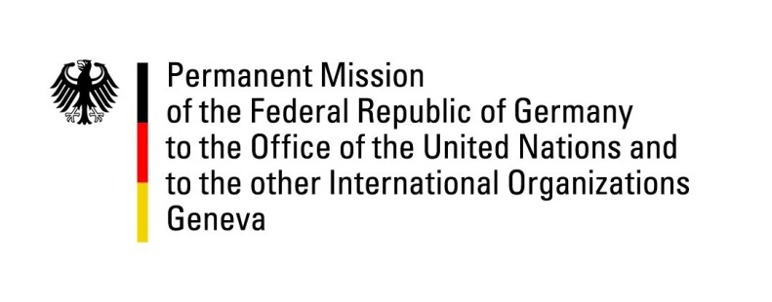

United Nations Human Rights Council
29th Session of the UPR Working Group

Geneva, 23 January 2018
---
Recommendations and advance questions
to
Israel

Mr. President,
Germany welcomes the delegation of Israel to the UPR and commends Israel for its engagement with the Human Rights Council and for progress made with regards to the rights of LGBTI persons.
At the same time, Germany remains concerned by the human rights situation, especially in the occupied Palestinian territories.
Germany offers the following recommendations:
1. To end practices of collective punishment such as the demolition of homes, revocation of residency permits in East Jerusalem and the closure of entire areas.
2. To limit the application of administrative detention to clearly defined and exceptional cases, in accordance with international law, and to refrain completely from holding minors in administrative detention.
3. To respect the rights of refugees as enshrined in the Geneva Refugee Convention and to refrain from implementing the policy of forcible relocation to third countries without ensuring that relocation agreements include protection safeguards and the overall legal framework is known by those who may volunteer for relocation.

Thank you Mr President.

Advance questions to Israel:

1. Which steps has Israel taken since the last review with regard to introducing the civil marriage for those persons in Israel who cannot or do not wish to be subjected to a religious marriage?
2. Which measures does Israel intend to take with regard to safeguarding the economic, social and cultural rights of the Bedouin community, in particular women and girls?
3. Which measures does Israel take to guarantee the human rights to safe drinking water and sanitation in Israel and in the occupied Palestinian territories?

