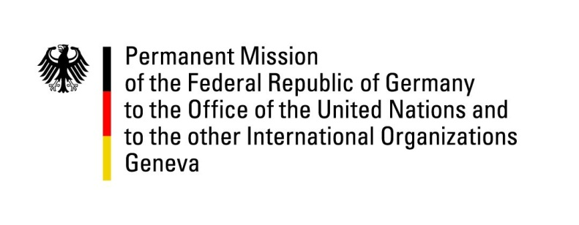

United Nations Human Rights Council
29th Session of the UPR Working Group

Geneva, 18th January 2018

German recommendations and advance questions
to
BURUNDI

Mr. President,
Germany welcomes Burundi to the UPR and recommends:

1. Fulfill its obligation as member of this Council and fully cooperate with the Commission of Inquiry on Burundi and with the team of three UN experts, and with the ICC, including by granting access.

2. Undertake independent, effective and impartial investigations into all allegations of serious human rights violations, such as extrajudicial executions and excessive use of force by security forces, intelligence services and Imbonerakure, and prosecute those.

3. Re-establish relations with the OHCHR and conclude the outstanding Memorandum of Understanding on the status of the office of the OHCHR in Bujumbura.

4. Establish a judicial mechanism to follow the work of the Truth and Reconciliation Commission to end impunity and to ensure that human rights violations are prosecuted.

5. Ensure humanitarian access and humanitarian space for all relevant actors, including human rights agencies and international NGOs, without discrimination, also by revising Articles 16-19 and 29 of the new charter on international NGOs.

Thank you.

German advance questions to Burundi:

- In line with Germany’s recommendation from the last UPR cycle, which had been accepted, what is the status of the Truth and Reconciliation Commission (TRC) and the independent special tribunal to examine war crimes? What will come next when the four year term ends this year? Will a judicial mechanism be established to accompany and follow the work of the TRC to end impunity and to ensure that human rights violations are prosecuted?
- Also in line with Germany’s recommendation from the last UPR cycle, what steps have been taken by Burundi to ensure the independence of judges?
- In light of the resolutions adopted at the 36th session of the Human Rights Council and the decision to deploy a team of experts of the Office of the High Commissioner for Human Rights, what steps does Burundi take to conclude the outstanding MoU on the status of the office of OHCHR in Bujumbura?
- Which steps does Burundi plan to take to ensure that all of the 200 African Union’s human rights and military observers can be deployed and fulfill their mandate adequately?

