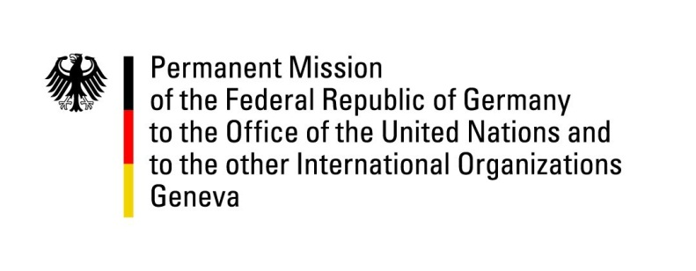

United Nations Human Rights Council

29th Session of the UPR Working Group

Geneva, 17 January 2018

German questions and recommendations to
Botswana

Thank you, Mr. President.

Germany welcomes the delegation of Botswana to the UPR and commends Botswana for the improvements it has made in access to health care, schooling and education. Botswana’s overall human rights record is noteworthy.

However, room for improvement remains in Botswana’s legislation and its implementation. Therefore, Germany offers the following recommendations:

- Ensure that the Office of the Ombudsman, as a National Human Rights Institution (NHRI) is independent and adequately financed in line with the Paris Principles.
- Protect LGBTI-persons from discrimination by amending sections 164, 165 and 167 of the Botswana Penal Code to decriminalize same-sex activities among consenting adults and by explicitly including sexual orientation and gender identity as listed grounds of non-discrimination in Section 3 of the Constitution;
- Establish a comprehensive monitoring mechanism on the treatment of children with the aim of disclosing cases of sexual abuse, mistreatment and neglect, including by introducing the possibility of taking children out of an environment which is not conducive for their development;
- Establish an official moratorium on executions and abolish the death penalty.

Thank you, Mr. President.

GERMAN ADVANCE QUESTIONS TO BOTSWANA:

- What steps are being taken to achieve full equality of women and reduce gender-based violence, inter alia by granting women equal inheritance rights and criminalizing martial rape?
- Despite numerous recommendations in the past UPR cycles, Botswana still applies the death penalty. Botswana has stated that it has not been able to initiate a public debate. What are Botswana’s plans regarding such a debate and the abolishment of the death penalty?

