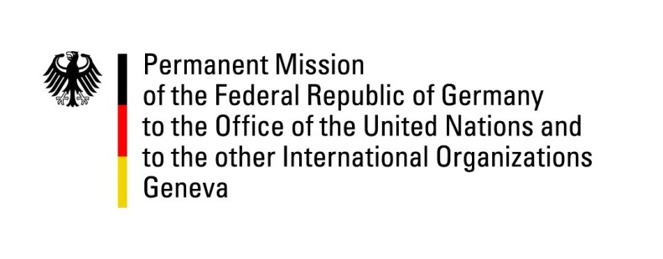

United Nations Human Rights Council

29th Session of the UPR Working Group

Geneva, 19 January 2018
German recommendations and advance questions
To Barbados

Thank you, Mr. President,

Germany welcomes the delegation of Barbados to the UPR. We commend Barbados for the ratification of the Convention on the Rights of Persons with Disabilities and its efforts of drafting an anti-discrimination law.

However, Germany remains concerned about the death penalty, and the use of corporal punishment of children. Therefore, Germany would like to offer the following recommendations:

- Abolish the death penalty for all crimes and ratify the Second Optional Protocol to the International Covenant on Civil and Political Rights;

- Ratify the Convention against Torture and its Optional Protocol;

- Abolish corporal punishment;

- Establish an independent national human rights institution, in accordance with the Paris Principles;

- Amend its laws to ensure gender equality between Barbadian mothers and fathers with respect to their ability to confer their nationality to their children in all circumstances.

Thank you, Mr. President
Germany’s advance questions to Barbados:
1. Given the record of not having carried out an execution in 33 years and given the de facto moratorium on executions, what steps is Barbados undertaking to forge a national consensus for the abolition of the death penalty?
2. Barbados is in the process of drafting an anti-discrimination legislation. How will this include and protect LGBTI persons?

