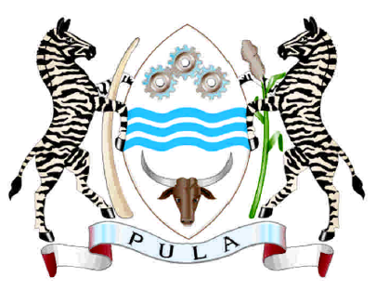

REPUBLIC OF BOTSWANA

CONCLUDING STATEMENT

BY

HONOURABLE EDWIN JENAMISO BATSHU

MINISTER OF NATIONALITY, IMMIGRATION AND GENDER AFFAIRS

BOTSWANA’S THIRD CYCLE

UNIVERSAL PERIODIC REVIEW

29TH SESSION OF THE UNIVERSAL PERIODIC REVIEW

17 January 2018

Geneva, Switzerland

Mr President,

- Thank you for giving me the floor once again,
- Botswana attaches great importance to the Universal Periodic Review (UPR) Process which allows for a candid and participatory evaluation of each other’s efforts in the promotion and protection of human rights.

- As I indicated in my presentation of the Botswana Review Statement, we may have fallen short as the Government to address all the issues that were raised since our last review However, we have taken note of your observations and shall endeavor to address them.

- This has been a very informative and fruitful dialogue and, we emerge with a richer knowledge, and a greater resolve to improve Botswana’s image and implementation record. Your invaluable contributions will go a long way towards ensuring the full enjoyment of human rights in our country.

- I therefore, wish to take this opportunity to thank all delegations for their participation and constructive engagement during our review. I also extend my deepest gratitude to out Troika and the UPR Secretariat for their facilitation throughout our review.

- Let me underscore that the same multi-stakeholder and participatory approach that informed our National Report preparation will be employed in the development of an Action Plan towards implementation of accepted recommendations.

- Allow me to also assure you that Botswana remains committed to ensuring implementation and monitoring of these recommendations. We will move steadfastly to respond to the remaining recommendations within a reasonable timeframe.

Thank you Mr. President.

