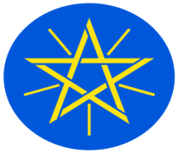
Statement
by
the Representative of the Federal Democratic Republic of Ethiopia on the Universal Periodic Review of the United Arab Emirates

Mr. President,
Ethiopia welcomes the delegation of the United Arab Emirates led by …….. to the 43rd Session of the UPR Working Group. We thank the delegation for the comprehensive national report and the oral update today.

Ethiopia commends the United Arab Emirates for implementing the recommendations received during previous UPR cycles, and for the Commitments to the Promotion of Human rights in an inclusive manner.

Ethiopia recommends to the United Arab Emirates to:
- advance institutional infrastructure and policy measures to the promotion of human rights;
- further strengthen measures taken to protection of the family and uphold the rights of children; and
- further strengthen its integrated social support programmes.

Finally, Ethiopia wishes success to the delegation of United Arab Emirates in its engagement with the UPR Working Group.

I thank you.

