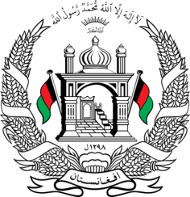
Permanent Mission of Islamic Republic of Afghanistan
Session of the UPR Working Group
Statement on the Review of Burundi

Thank you,
Afghanistan welcomes the distinguished delegation of Burundi to this UPR working group session. We express our appreciation for their engagement with the UPR and for their efforts towards fulfillment of their human rights obligations since the previous cycle.
Afghanistan notes with appreciation that, since the last review cycle, Burundi has taken the necessary steps to ensure the independence of the National Independent Human Rights Commission of Burundi.
However, we share the concerns about the low rate of secondary school completion among girls, caused partly by sexual violence and unwanted pregnancies.

In the spirit of constructive engagement, we wish to make the following recommendations:
- Establish a national legal aid program for the most vulnerable populations, especially women and girls victims of violence;

- Ensure that allegations of violence against women were thoroughly investigated and perpetrators were brought to justice.

Finally, we wish Burundi every success in the review process.

I thank you.

