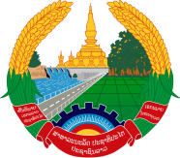
Statement by the delegation of the Permanent Mission of the Lao PDR to the United Nations Office and other International Organizations in Geneva
at the 43rd Session of the UPR Working Group
Geneva, 1-12 May 2023
_________

Review of Serbia, 10 May 2023 (09:00-12:00 hours)

Mr. President,
My delegation warmly welcomes and thanks the delegation of Serbia for the comprehensive report.

The Lao PDR welcomes Serbia’s active cooperation with the United Nations human rights mechanisms. We commend the legal and institutional progress on the promotion and protection of human rights, including the adoption of the Law on Gender Equality.

My delegation would like to recommends the followings:

- Continue efforts to implement the Strategy for Gender Equality 2022-2030 and the corresponding Action Plan; and

- Strengthen efforts toward promoting and protecting the human rights of vulnerable groups, including women, children and the persons with disabilities.

I wish Serbia every success in this UPR review.

I thank you, Mr. President.

