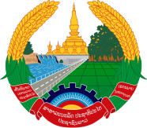
Statement by the delegation of the Permanent Mission of the Lao PDR to the United Nations Office and other International Organizations in Geneva
At the 43rd Session of the UPR Working Group
Geneva, 1-12 May 2023
_________

Review of Mali, 2 May 2023 (14:30-18:00 hours)

Mr. President,
My delegation would like to thank the delegation of Mali for a comprehensive report.

The Lao PDR welcomes the ongoing cooperation between the Government of Mali and the United Nations and its mechanisms. We commend the progress made by Mali in improving the national legal and institutional frameworks for the promotion and protection of human rights in the country.

My delegation would like to make two recommendations:

- Strengthen the implementation of the Ten-Year Educational Development Programme 2019-2028 to ensure the right to quality education for all; and

- Continue the ongoing efforts toward implementing the Agreement on Peace and Reconciliation.

I wish Mali a successful UPR review.

I thank you, Mr. President.

