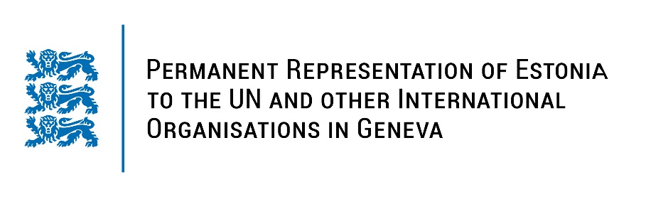
Universal Periodic Review of the Republic of Serbia
10 May 2023
Intervention by the delegation of Estonia

Estonia welcomes the delegation of Serbia to the 43rd UPR session and thanks for the report and the information provided today.

Estonia notes positively the adoption of new laws for implementing constitutional reform and encourages Serbia to continue constitutional and judiciary reforms to strengthen the independent functioning of the judiciary. Estonia commends Serbia for introducing the Law on the Ombudsman (2022) to protect the rights of children. Estonia notes with appreciation the adoption of the Law on Gender Equality (2021) to further protect women from gender-based and domestic violence.

In line with the previous cycle, Estonia would like to recommend to Serbia to:
- explicitly prohibit corporal punishment of children in all settings, including in the home;
- continue to effectively investigate reports of intimidation, harassment and attacks against journalists and media workers;
- improve transparency of media ownership and ensure the independence of media outlets to protect freedom of expression;
- provide adequate funding for implementation the The Strategy for the Prevention and Fight against Gender-Based Violence against Women and Domestic Violence for the Period 2021-2025;
- conduct awareness-raising campaigns about the nature of domestic violence.

Estonia wishes the delegation of Serbia a successful review meeting.

I thank you!

