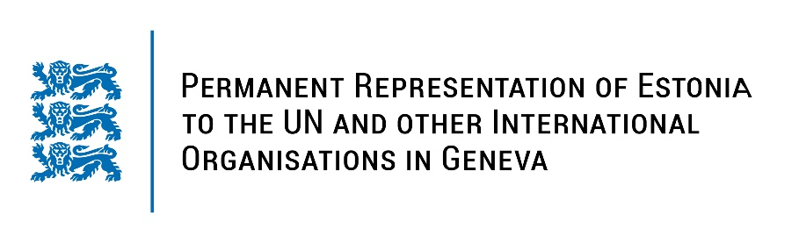
Universal Periodic Review of the Principality of Liechtenstein
9 May 2023
Intervention by the delegation of Estonia

Estonia welcomes the delegation of Liechtenstein to the 43rd UPR session and thanks for the report and the information provided today.

Estonia appreciates Liechtenstein’s continued work to promote and protect human rights in the country. We highly acknowledge Liechtenstein’s active role in promoting and protecting women’s rights and strengthening and advancing gender equality. We commend Liechtenstein for the ratification of the Council of Europe Convention on Preventing and Combating Violence against Women and Domestic Violence (the Istanbul Convention). We would like to congratulate Liechtenstein for becoming a member of the UN Commission on the Status of Women (CSW) again for the period 2023-2027.

In line with the previous cycle, Estonia would like to recommend to Liechtenstein to:
- ratify the Convention of the Rights of Persons with the Disabilities (CRPD) as a follow-up step after the signing of the convention;
- decriminalize defamation and include it as part of the civil code in accordance with international standards.

In addition, Estonia would like to recommend:
- encourage the Association for Human Rights to apply for A status accreditation with the Global Alliance of National Human Rights Institutions and allocate adequate and sustainable human, technical and financial resources to it.

Estonia wishes the delegation of Liechtenstein a successful review meeting.

I thank you!

