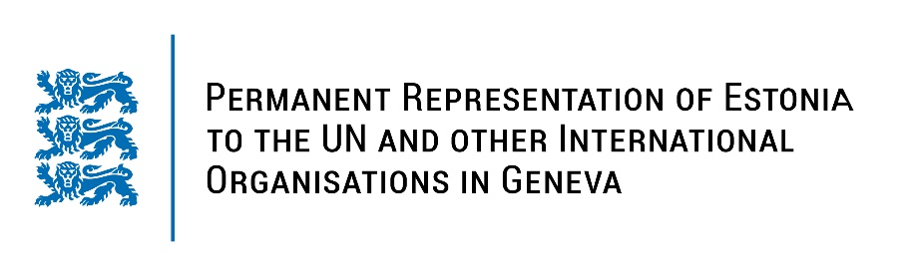
Universal Periodic Review of the United Arab Emirates
8 May 2023
Intervention by the delegation of Estonia

Estonia welcomes the delegation of the United Arab Emirates to the 43rd UPR session and thanks for the report and the information provided today.

Estonia notes with appreciation the UAE’s efforts to strengthen the promotion and protection of women’s rights and promote gender equality. We welcome the adoption of the Family Protection Policy (2019) addressing domestic violence, and the introduction of the legislation aiming at ensuring equal pay for men and women in the private sector (2020). We note with appreciation the establishment of the National Human Rights Institution.

In line with the previous cycle, Estonia would like to recommend to the UAE to:
- take further steps to ensure the respect of the right to freedom of opinion and expression both online and offline, including ending the harassment and intimidation of human rights defenders;
- decriminalize defamation and include it as part of the civil code in accordance with international standards;
- explicitly prohibit corporal punishment of children in all settings, including in the home;
- ratify the ICCPR and the Second Optional Protocol to the ICCPR aimed at the abolition of the death penalty.

Estonia wishes the delegation of the United Arab Emirates a successful review meeting.

I thank you!

