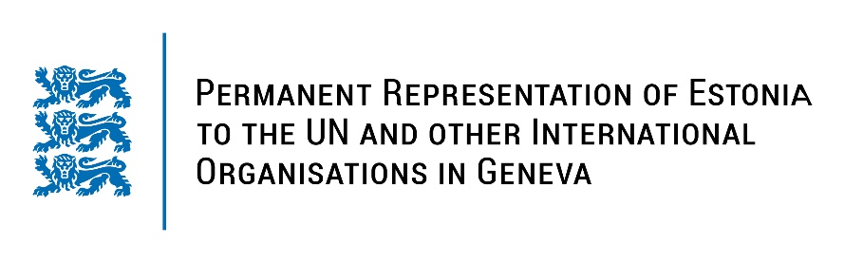
Universal Periodic Review of the Republic of Montenegro
8 May 2023
Intervention by the delegation of Estonia

Estonia welcomes the delegation of Montenegro to the 43rd UPR session and thanks for the report and the information provided today.

Estonia appreciates Montenegro’s active role as a member of the UN Human Rights Council and all its efforts to promote and protect the human rights. Estonia commends Montenegro for its efforts to fight corruption, including by strengthening the independence and effective functioning of the judiciary. We note with appreciation Montenegro’s efforts to protect journalists, including by forming the Commission for Monitoring Investigations of Attacks on Journalists.

In line with the previous cycle, Estonia would like to recommend to Montenegro to:
- continue to effectively investigate reports of intimidation, harassment and attacks against journalists and media workers and bring perpetrators to justice;
- ensure that all alleged cases of domestic violence are thoroughly investigated, perpetrators prosecuted and victims adequately protected and compensated;
- conduct awareness-raising campaigns about the nature of domestic violence and the power dynamics associated with gender.

Estonia wishes the delegation of Montenegro a successful review meeting.

I thank you!

