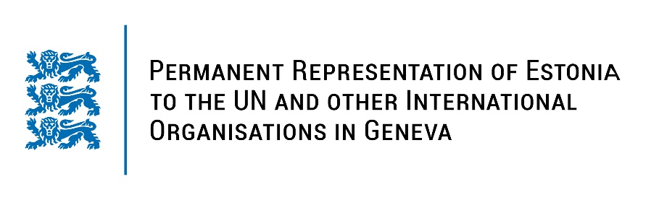
Universal Periodic Review of the Grand Duchy of Luxembourg
4 May 2023
Intervention by the delegation of Estonia

Estonia welcomes the delegation of the Grand Duchy of Luxembourg to the 43rd UPR session and thanks for the report and the information provided today.

Estonia appreciates Luxembourg’s active role as a member of the UN Human Rights Council and all its efforts to promote and protect the human rights. We commend the ratification of the Council of Europe Convention on Preventing and Combating Violence against Women and Domestic Violence (Istanbul Convention) and the adoption a new five-year National Action Plan on the Implementation of the Convention on the Rights of Persons with Disabilities (for the period 2019-2024). We commend Luxembourg for its achievements in reducing the gender pay gap, which is the lowest in the European Union.

In line with the previous cycle, Estonia would like to recommend to Luxembourg to:
- decriminalize defamation and include it as part of the civil code in accordance with international standards.

In addition, we recommend to:
- continue to promote increased representation of women at all levels of public administration and in management positions in the private sector;
- encourage the reporting of and improve the identification of the cases of gender based violence and domestic violence.

Estonia wishes the delegation of Luxembourg a successful review meeting.

I thank you!

