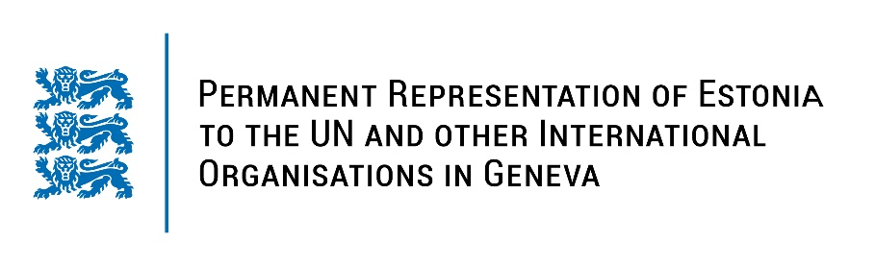
Universal Periodic Review of Burundi
4 May 2023
Intervention by the delegation of Estonia

Estonia welcomes the delegation of Burundi to the 43rd UPR session and thanks for the report and the information provided today.

Estonia appreciates Burundi’s commitment to strengthen the promotion and protection of human rights and the country’s introduction of new laws to achieve these goals. We commend Burundi for its advances regarding to the country’s work to fight against human trafficking. Estonia notes with appreciation the reaccreditation of the Independent National Human Rights Commission with A-status and strengthening the other national human rights institutions and mechanisms.

In line with the previous cycle, Estonia recommends to Burundi to put an immediate end to any harassment and intimidation against human rights defenders, journalist and media workers and to refrain from criminalizing their lawful activities.

In addition, we would like to recommend to:
- implement the ICPD25 commitment in order to reduce preventable maternal deaths, including by ensuring access to sexual and reproductive health services;
- ensure that young people and adolescents have free and unhindered access to accurate information on sexual and reproductive health;
- ratify the Second Optional Protocol to the International Covenant on Civil and Political Rights, aiming at the abolition of the death penalty.

Estonia wishes the delegation of Burundi a successful review meeting.

I thank you!

