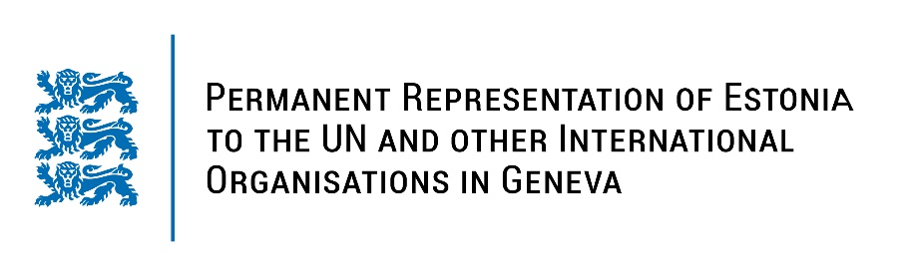
Universal Periodic Review of Botswana
3 May 2023
Intervention by the delegation of Estonia

Estonia welcomes the delegation of Botswana to the 43rd UPR session and thanks for the report and the information provided today.

Estonia appreciates Botswana’s continued attempts to improve its framework for human rights protection in the country. We commend Botswana for its continued work for implementing its Poverty Eradication Programme. Estonia applauds Botswana for acceding to the conventions on Child Abduction, Adoption and Child Support and ratifying the Convention on the Rights of Persons with Disabilities.

In line with the previous UPR cycle, Estonia would like to recommend to Botswana to:
- establish a moratorium on executions with a view to fully abolishing the death penalty;
- explicitly prohibit corporal punishment of children in all settings, including in the home, school and in penal institutions.

In addition, we recommend to:
- take further measures to combat human trafficking, including child trafficking, through the enforcement and full implementation of the Anti-Human Trafficking Act;
- develop and implement strategies and policies to combat patriarchal attitudes and stereotypes and discrimination against women;
- introduce free and confidential sexual and reproductive health services, information and education for adolescents.

Estonia wishes the delegation of Botswana a successful review meeting.

I thank you!

