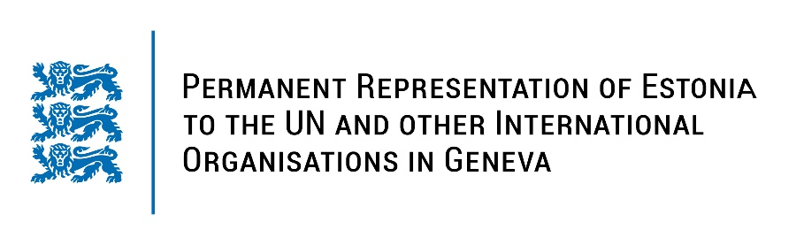
Universal Periodic Review of Mali
2 May 2023
Intervention by the delegation of Estonia

Estonia welcomes the delegation of Mali to the 43rd UPR session and thanks for the report and the information provided today.

Estonia notes with appreciation that the National Human Rights Commission of Mali was accredited with category A-status and Mali has welcomed the visits by the Independent Expert on the situation of human rights in Mali. Estonia is worried about the increased arbitrary arrests, detentions, enforced disappearances and killings of civilians. Therefore we welcome Mali’s efforts to combat impunity, in particular among the defence and security forces.

Estonia would like to recommend to Mali to:
- revise and adopt the law on child protection to include the criminalization of the recruitment and use of children below the age of 18;
- ratify the Second Optional Protocol to the International Covenant on Civil and Political Rights, aiming at the abolition of the death penalty;
- implement the ICPD25 commitment to achieve zero unmet need for family planning, including by ensuring sexual and reproductive health services;
- adopt the bill on gender-based violence, and take specific measures to prevent and combat such violence.

Estonia wishes the delegation of Mali a successful review meeting.

I thank you!

