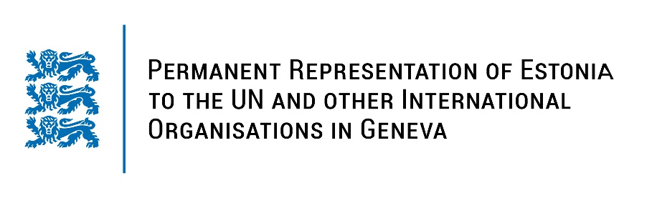
Universal Periodic Review of Romania
2 May 2023
Intervention by the delegation of Estonia

Estonia welcomes the delegation of Romania to the 43rd UPR session and thanks for the report and the information provided today.

Estonia appreciates Romania’s commitment to anticorruption, as the country is currently implementing its 6th National Anticorruption Strategy for 2021-2025. We commend Romania for its efforts to implement the national strategy 2022-2027 for the promotion of equal opportunities between women and men and the prevention and combating of domestic violence.

Estonia would like to recommend to Romania to:
- adopt and implement further policies and measures to prevent gender discrimination in the workplace and to protect women from violence and harassment in the workplace;
- undertake educational and awareness-raising campaigns aimed at eliminating harmful gender stereotypes;
- ensure that rights to freedom of expression and peaceful assembly are upheld, including ensuring that the right to peacefully protest is not unlawfully restricted.

Estonia wishes the delegation of Romania a successful review meeting.

I thank you!

