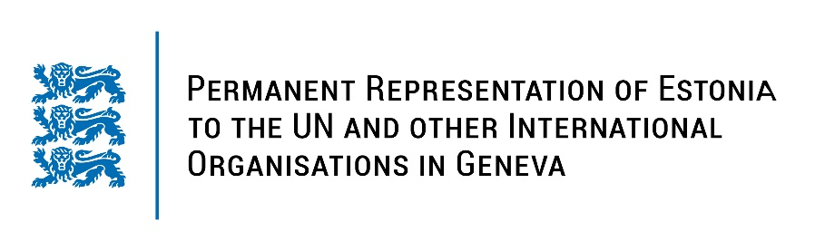
Universal Periodic Review of France
1 May 2023
Intervention by the delegation of Estonia

Estonia welcomes the delegation of France to the 43rd UPR session.

Estonia appreciates France’ role in promoting human rights and a diversified level of human rights protection across the country. Estonia commends France for contributing to and implementing the Women, Peace and Security Agenda and adopting the third national action plan (2021-2025). We welcome the introduction of a new National Plan to Combat Racism, Anti-Semitism and Discrimination. Finally, Estonia is pleased with France’s continued support and implementation of policies to ensure that transgender people can more easily obtain legal recognition through transparent processes.

Estonia would like to recommend to France to:
- take further measures to address all forms of violence against women, by both encouraging the reporting of and improving the identification of the cases of violence against women and domestic violence;
- ensure that all law enforcement officials, prosecutors, judges and lawyers receive systematic mandatory training on fundamental and human rights, including appropriate training how to effectively deal with cases of violence against women.

Estonia wishes the delegation of France a successful review meeting.

I thank you!

