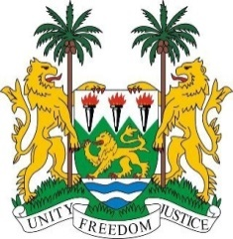
SIERRA LEONE
43rd Session of the UPR

Liechtenstein

9 MAY 2023

Mr President,
Sierra Leone welcomes H.E Ms. Dominique Hasler, Minister of Foreign Affairs, Education and Sports and the distinguished delegation of Liechtenstein and thanks it for the presentation of its national report.
We commend Liechtenstein`s decision to fully integrate and mainstreaming the SDGs into its government`s programmatic agenda and for ratifying the Istanbul Convention.
We further commend Liechtenstein for its cumulative funding in supporting diverse initiative aimed at equitable access to COVID 19 vaccines.
We welcome parliament`s passage of a supplementary budget aiming at increasing humanitarian assistance and development cooperation and for steps taken to close the gender wage gap, an assurance for better life and improved status for women.
We note with appreciation that majority of our recommendations during the third cycle were accepted by Liechtenstein. We invite Liechtenstein to reconsider the noted recommendations. In a spirit of constructive dialogue, we recommend the following:
1. Take concrete steps to strengthen efforts to combat human trafficking especially in women and girls.
2. Fully apply the provisions of CEDAW with a view to advancing women`s right and gender equality.
3. Establish and / or expedite the process of a National Human Rights Institution in full compliance with the Paris Principles.
We wish Liechtenstein success in this fourth review cycle.

Thank you, Mr President

