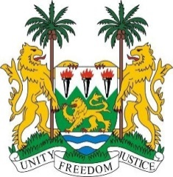
SIERRA LEONE
43rd Session of the UPR

United Arab Emirates

8 MAY 2023

Mr President,
Sierra Leone welcomes H.E. Ms. Shama Sahail Faris Ghanem Al-Mazrui, Minister of Community Development, and the distinguished delegation of the United Arab Emirates and thanks them for the presentation of their national report.
My delegation commends the United Arab Emirates for the establishment of the National Human Rights Institution in 2021 and other strategic policies focused on advancing human rights.
We welcome other striking socio-economic and political gains of the United Arab Emirates including its 6th successive lead in the fight against corruption in the Middle East and North Africa.
My delegation, however, notes the existing gaps, and in the spirit of constructive dialogue, recommends that the United Arab Emirates:
1. Ratify the Optional Protocols to the ICCPR aiming at the abolition of the death penalty.
2. Consider ratifying the Optional Protocol to the Convention against Torture and Other Cruel, Inhuman or Degrading Treatment.
3. Abolish the ‘Kafalah system and / or replace it with other policies focused on human rights-based approach.
Sierra Leone wishes the United Arab Emirates success in this fourth review cycle.

Thank you, Mr President

