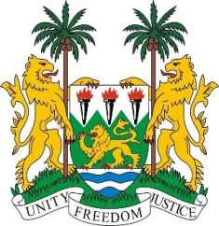
SIERRA LEONE

43rd Session of the UPR

BARBADOS

5 May 2023

Mr. President,

Sierra Leone welcomes Hon. Kerrie D. Symmonds, Minister of Foreign Affairs and the distinguished high-level delegation of Barbados and thanks it for the presentation of its national report.

We congratulate Barbados on becoming a signatory to the UN Treaty on the Prohibition of Nuclear Weapons.

My delegation notes that despite human resource challenges, Barbados has ratified six (6) out of nine (9) core international human rights instruments.

We commend Barbados for its efforts in the fight against corruption. Notably, the enactment of the Prevention of Corruption Act in 2021.

We invite Barbados to reconsider our noted recommendations during the third review cycle and in a constructive spirit, recommend as follows:

- Consider ratifying the Optional Protocols to the Convention on the Rights of the Child.
- Consider ratifying International Convention for the Protection of All Persons from Enforced Disappearance.
- Increase the minimum age of criminal liability and criminalise child marriage.
- Consider ratifying the UN Convention against Torture and Other Cruel, Inhuman or Degrading Treatment or Punishment.

Sierra Leone wishes Barbados every success in this fourth review cycle.

Thank you, Mr. President.

