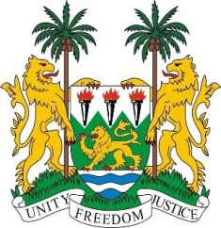
SIERRA LEONE
43rd Session of the UPR

LUXEMBOURG

4 MAY 2023

Mr President,

Sierra Leone welcomes H.E Mr. Jean Asselborn, Minister of Foreign Affairs and European Affairs and the distinguished delegation of Luxembourg and thanks them for the presentation of its national report.

We commend Luxembourg for submitting up-to-date report to the treaty bodies and her determination in fulfilling its reporting obligations including its standing to all thematic special procedures. We note with a deep sense of appreciation that all four of our third-cycle recommendations enjoy the support of Luxembourg.

We welcome the establishment of the office of the Ombudsman for Children and Young Persons and the National Action Plan on Equality between Women and Men with priorities on areas accepted as key development indicators.
In the spirit of constructive dialogue, my delegation recommends that Luxembourg:
1. Expedite the process of enacting laws that would guarantees aggravated circumstances for crimes that include hate speech, racism and racial discrimination provisions in the criminal code.

2. Expedite the process of completing a national strategy in combating antisemitism and consider a similar policy against Islamophobia.

Sierra Leone wishes Luxembourg a successful review cycle.

Thank you, Mr President.

