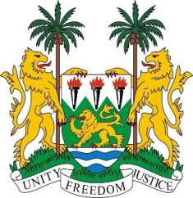
SIERRA LEONE
43rd Session of the UPR

BURUNDI

4 May 2023

Mr. President,

Sierra Leone welcomes H.E Mrs. Imelde Sabushimiike, Minister of National Solidarity, Social Affairs, Human Rights and Gender and the distinguished delegation from Burundi and thanks it for the presentation of its national report.

Sierra Leone applauds the measures taken to prevent and punish trafficking in person by setting up a consultation and monitoring commission in 2022. It is encouraging that Burundi renewed the mandate of the Office of the Ombudsman and Truth and Reconciliation Commission (TRC) in 2022.

My delegation notes, with satisfaction that majority of our recommendations were accepted by Burundi during its third review cycle. We encourage Burundi to reconsider the noted recommendation. In a spirit of constructive engagement, we recommend for due consideration of Burundi as follows:

- Strengthened its engagements and cooperation with Human Rights Council mechanisms including regional mechanisms.
- Take concrete steps to submit outstanding periodic reports to treaty bodies including seeking technical assistance and capacity building.
- Guarantee the independence of the Human Rights Commission and provide it with both material and financial resources to enable it fulfil its mandates.
- Consider to ratifying the Second Optional Protocol to the ICCPR with a view to abolishing the death penalty.

Sierra Leone wishes Burundi every success in completing its fourth review cycle.

Thank you, Mr. President.

