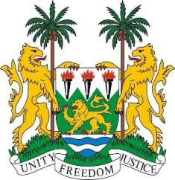
SIERRA LEONE

43rd Session of the UPR

BAHAMAS

3 May 2023

Mr President,

Sierra Leone welcomes the distinguished high-level delegation of Bahamas to this review session and thanks them for their comprehensive presentation.

We applaud the government and people of Bahamas for the sense of resilience and fortitude exhibited following its twin disaster of Hurricane Dorian and the Covid 19 Pandemic.

We welcome the enactment of the Disaster Risk Management Act of 2022 which essentially consolidates relevant MDAs for adequate response to disasters. We heartily congratulate Bahamas for successfully completing its first term as the first member state of the Caribbean Community (CARICOM) to the HRC.

We kindly invite Bahamas to reconsider our recommendations which were submitted during the third cycle review and in a spirit of constructive engagement recommend the following:

- Ratify the International Convention on the Protection of the Rights of All Migrant Workers and Members of Their Families.
- Ratify the International Convention for the Protection of All Persons from Enforced Disappearance.
- Consider ratifying the Optional Protocol to the OPCAT

Sierra Leone wishes the Bahamas every success in completing their fourth review cycle.

Thank you, Mr. President.

