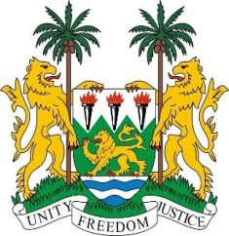
SIERRA LEONE
43rd Session of the UPR

BOTSWANA

3 May 2023

Mr. Vice President,

Sierra Leone warmly welcomes the Hon. Machana Ronald Shamukuni, Minister of Justice and the esteemed delegation from Botswana and thanks it for the presentation of its national report.

We commend Botswana for its continued engagement and cooperation with special procedures and treaty bodies. We welcome the enactment of legislation and other actions taken in addressing SGV.

We regret that majority of our third-cycle recommendations were noted. We invite Botswana to reconsider these recommendations.

In closing the existing gaps and in a constructive spirit, we recommend as follows:

- Maintain and promote the full enjoyment of the rights of expression and freedom of assembly.

- Consider to implementing and / or operationalising the 2030 Eastern and Southern African Ministerial Commitment with a focus on combating SGV and keep advancing gender equality, health and education of adolescents and other vulnerable persons.

- Consider to amending the Child Rights Act to criminalize child marriage in both customary and religious marriages.

- Consider ratifying the Optional Protocol to the OPCAT

Sierra Leone wishes Botswana review cycle.

Thank you, Mr. Vice President.

