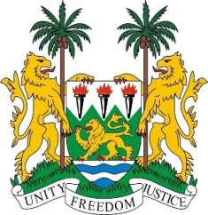
SIERRA LEONE

43rd Session of the UPR

MALI

2 MAY 2023

Mr President,

Sierra Leone warmly welcome the Hon. Mamadou Kassogue Minister of Justice and the distinguished delegation of Mali and thanks them for the presentation of their national report.

We commend the government of Mali for its remarkable strides in the promotion of gender equality and women`s empowerment. We welcome in particular, the signing of the National Plan of Action 2019-2023 on UN Security Council Resolution 1325 (2000) on women and peace and security.
We applaud the enactment of the Electoral Law Act No.2022-019 of 24 June 2022 and the 24 months’ timetable for election. This will no doubt provide strategic guide in the conduct of free, fair, credible and transparent elections.
In a spirit of constructive engagement, we recommend as follows:
1. Strengthen its cooperation and engagement with special procedure mandate holders.
2. Criminalize the recruitment of child soldiers.
3. Consider to ratify the OPCAT.
Sierra Leone wishes Mali every success in completing its fourth review cycle.

Thank you, Mr President.

