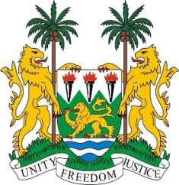
SIERRA LEONE

43rd Session of the UPR

FRANCE

1 MAY 2023

Mr President,

Sierra Leone welcomes H.E Ms. Isabelle Lonvis-Rome Minister for Gender Equality, Diversity and Equal Opportunities and the distinguished French delegation to the fourth cycle UPR and thanks them for the presentation of its report.

We commend France for its continued engagement and cooperation with the Human Rights Council and special procedure mandate holders.

We note with gratifying commendation that all four of our third cycle UPR recommendations enjoyed the support of France. We commend France for taking concrete steps in improving the normative and structural framework for the protection and promotion of human rights. We note in particular the Additional Protocol No.16 to the Convention for the Protection of Human Rights and fundamental freedoms.

Despite these achievements, we note the existing gaps and in a constructive spirit recommend as follows:

- Continue to take concrete measures to combat systemic discrimination, racism and xenophobia online and offline.
- Consider to review relevant legislation with a view to defining consent and provide regular care for victims of sexual violence.

Sierra Leone wishes France every success in completing its fourth review cycle.

Thank you, Mr President.

