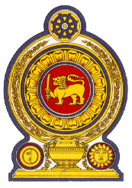

43 Session of the UPR Working Group, 1 to 12 May 2023

Statement by Sri Lanka on Liechtenstein

09 May 2023

Mr. President,

Sri Lanka thanks the delegation of Liechtenstein for the presentation made.

We note the measures taken by Liechtenstein to improve the human rights situation in the country including incorporation of the offence of torture as an explicit crime in the Criminal Code in 2019 as well as the amendments introduced to the Social Assistance Act in 2021. We commend the launch of the Finance Against Slavery and Trafficking Initiative and the revision of the Foreigners Act to prevent human smuggling. We also note the measures taken by Liechtenstein to close the gender pay gap.

In a constructive spirit, Sri Lanka recommends that Liechtenstein:

1. Sign and ratify the International Convention on the Protection of the Rights of All Migrant Workers and Members of Their Families

2. Strengthen efforts to eliminate discrimination against women in the labour market

3. Take further measures to prohibit discrimination against women in education and enhance access to higher education for migrant children.

We wish Liechtenstein success in its UPR engagement.

