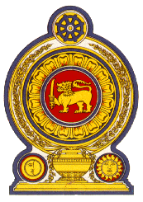

43rd Session of the Universal Periodic Review

Review of Israel

09 May 2023

Statement by the Democratic Socialist Republic of Sri Lanka

Mr President,

Sri Lanka welcomes the delegation of Israel and the presentation made.

Sri Lanka notes Israel’s progress in protecting and promoting human rights since its last UPR. Sri Lanka commends progressive legislative reforms by Israel including the 2016 Amendment No. 35 to Compulsory Education Law, to promote the rights of the child.

In a constructive spirit, Sri Lanka recommends that Israel:

- Ratifies the International Convention on the Protection of the rights of All Migrant Workers and Members of their Families.

We wish Israel success in its UPR engagement.

Thank you.

