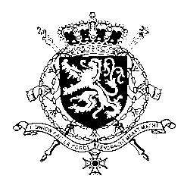
Représentation permanente de la Belgique auprès des Nations Unies et auprès des institutions spécialisées à Genève

WG UPR 43 – Montenegro
Belgian intervention
8 May 2023

President,

Belgium welcomes the efforts and positive steps made by Montenegro since its previous UPR. Notwithstanding these efforts, important challenges remain, in particular regarding women’s rights and gender-based violence, the fight against torture or ill-treatment and birth registration.

Belgium therefore recommends the government of Montenegro to:

R1. Ensure that children’s nationality status is determined as soon as possible after birth in order to ensure that otherwise stateless children born in Montenegro acquire a nationality.
R2. Ensure that suspected perpetrators of torture are immediately suspended from official duties and for the duration of the investigation.
R3. Amend legislation to criminalize marital rape and establish adequate punishment for perpetrators and redress for victims of gender-based violence.

Thank you, President

