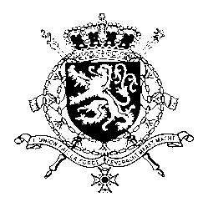
Représentation permanente de la Belgique auprès des Nations Unies et auprès des institutions spécialisées à Genève

WG UPR 43 – Barbados
Intervention of Belgium
5 May 2023

President,
Belgium acknowledges the progress made by Barbados since its previous UPR, notably regarding non-discrimination.

However, in order to further increase the protection of human rights, Belgium recommends to:

R1. Expedite the adoption of the draft law on juvenile justice, as well as the Child Justice Bill, in accordance with the International Convention on the Rights of the Child, including by prohibiting corporal punishment in all circumstances, as well as clearly and explicitly define and prohibit sexual abuse and exploitation of children.

R2. Legalize same-sex unions.

As a strong proponent of the abolition of the capital punishment, we recommend the government of Barbados at a minimum to:

R3. Reduce the offences for which the death penalty may be imposed to the most serious crimes as well as to commute death sentences.

And to consider further progress on this issue.

Thank you, President.

