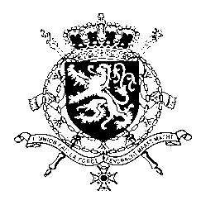
Représentation permanente de la Belgique auprès des Nations Unies et auprès des institutions spécialisées à Genève

WG UPR 43 – Bahamas
Intervention of Belgium
3 May 2023

President,
Belgium acknowledges the progress made by the Bahamas in different fields since its previous UPR.

However, in order to further increase the protection of human rights, Belgium recommends to:

R1. Expedite the passage of the bill to prohibit marital rape in the penal code.
As a strong proponent of abolition of capital punishment, we recommend the government of Bahamas at a minimum to:

R2. Reduce the offences for which the death penalty may be imposed to the most serious crimes, in accordance with Article 6 of the International Covenant on Civil and Political Rights.

And to consider further progress on this issue.

Belgium welcomes the ratification of the Convention against torture by the Bahamas in 2018 and recommends to

R3. Bring legislation, including the penal code, in line with the Convention against Torture and Other Cruel, Inhuman or Degrading Treatment or Punishment.

I thank you, President.

