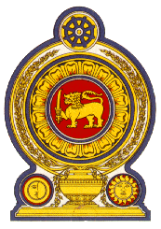

Statement by Sri Lanka

43 Session of the UPR

Review of the United Arab Emirates – 8 May 2023

Mr. President,

Sri Lanka warmly welcomes the delegation of the United Arab Emirates and appreciates its presentation of a comprehensive national report and engagement with the HRC today.

We note the adoption by the United Arab Emirates of an interconnected and integrated system of national policies and strategies to promote human rights.

We also note the 2015–2021 national strategy for the empowerment and advancement of women and the 2022–2026 gender-balance strategy, which have strengthened national efforts for the promotion of women.

We take this opportunity to recommend that the UAE :

- Further strengthens measures for the protection of children including through the family protection policy of 2019.

- Considers ratifying the International Convention on the Protection of the Rights of All Migrant Workers and Members of Their Families.

- Takes further measures towards ensuring that all children have access to free education and health care.

- Further strengthens the initiative of the National Committee to Combat Human Trafficking to ensure protection from human trafficking

Finally, we wish the United Arab Emirates success in its UPR engagement.

I thank you.

