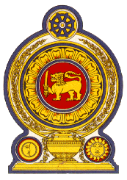

Statement by Sri Lanka

43 Session of the UPR

Review of Bahamas – 3 May 2023

Mr. President,

Sri Lanka welcomes the delegation of Bahamas and appreciates its presentation of a comprehensive national report and engagement with the HRC today.

We note that Bahamas established an Inter-Ministry Committee on Trafficking in Persons and a Trafficking in Persons Task Force.

We also note the efforts by Bahamas to put an end to the issue of inequality on citizenship transmission in the country.

We take this opportunity to recommend that the Bahamas :

- Establish a national human rights institution in accordance with the Paris Principles.

- Takes measures towards ending gender inequality.

- Ratify the International Convention on the Protection of the Rights of All Migrant Workers and Members of Their Families.

- Build the capacity of the judiciary, law enforcement officers, border police, social workers and health-care professionals to address issues related to human trafficking.

Finally, we wish the Bahamas success in its UPR engagement.

I thank you.

