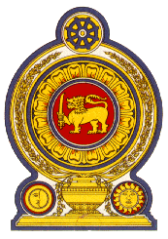

43 Session of the UPR Working Group, 1 to 12 May 2023

Statement by Sri Lanka on Romania

02 May 2023

Mr. President,

Sri Lanka welcomes the delegation of Romania to this review and appreciates the presentation made.

We welcome the implementation by Romania of the 6th National Anticorruption Strategy (NAS) and the "No discrimination!" project implemented at the national level by the Romanian Police on prevention of discrimination and hate crimes. We also commend the inclusion of Human rights education in the compulsory school curriculum and the adoption of the National Strategy on Social Inclusion and Poverty Reduction for 2022- 2027.

In a spirit of constructive dialogue, Sri Lanka recommends that Romania:

- Take further measures for protection of migrant workers including through the ratification of the International Convention on the Protection of the Rights of All Migrant Workers and Members of Their Families
- Intensify efforts to counter human trafficking in particular on child trafficking and provide protection to victims.

Sri Lanka wishes Romania success in its UPR review.

