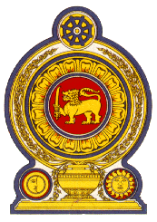

43rd Session of the Universal Periodic Review

Review of Tonga

01 May 2023

Statement by the Democratic Socialist Republic of Sri Lanka

Mr President,

Sri Lanka extends a warm welcome to the delegation of Tonga and appreciates the presentation made.

We commend Tonga’s progress in protecting and promoting human rights since its last UPR. Sri Lanka notes the National Women’s Empowerment and Gender Equality Tonga Policy (WEGET) and Strategic Plan of Action 2019-2025.

In a constructive spirit, Sri Lanka recommends that Tonga:

-Promotes the rights of the child by enhancing access to education and enrollment capacities.

-Continues to advance the rights of women and their public participation.

We wish Tonga success in its UPR engagement.

